Design Document of
Hotel Booking System

Content
1. Requirement analysis - 2 -
1.1 System architecture diagram - 2 -
1.2 Use case diagram - 2 -
1.3 Middleware selection - 3 -
2. System design - 3 -
2.1 Database design - 3 -
2.2 Main method specification - 5 -
2.3 Class diagram - 7 -
3. System realization - 9 -
3.1 User interface - 9 -
3.2 Deployment diagram - 12 -

1. Requirement analysis

1.1 System architecture diagram
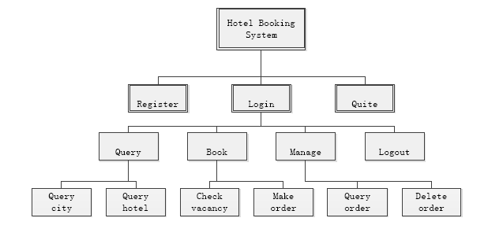
Figure 1: System architecture diagram
As we can see from Figure 1, when the Hotel Booking System is running, users can choose to register, login and quite. After login, there are 4 main modules, including query, book, manage and logout. Query module includes “query city” and “query hotel”; Book module includes “check vacancy” and “make order”; Manage module includes “query order” and “delete order”.

1.2 Use case diagram
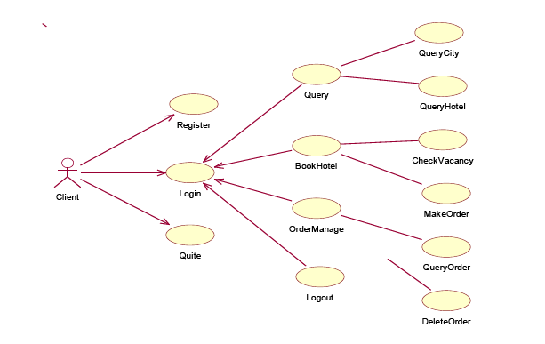
Figure 2: Use case diagram

1.3 Middleware selection
According to the requirement, there are 3 different middlewares to be deployed. The client communicates with broker server through RMI, and the broker server communicates with hotel servers through both RMI and Corba. In addition, WebService will also to be used in this project.

2. System design

2.1 Database design
2.1.1 User table: user
Table 1: User table
Field Name | Type | Data Integrity Constraints | Meaning
userid | VARCHAR(255) | PK | User ID
psw | VARCHAR(255) |  | User password

2.1.2 City table: city
Table 2: City table
Field Name | Type | Data Integrity Constraints | Meaning
cityid | VARCHAR(255) | PK | City ID
cityname | VARCHAR(255) |  | City name

2.1.3 Hotel table: hotel
Table 3: Hotel table
Field Name | Type | Data Integrity Constraints | Meaning
hotelid | VARCHAR(255) | PK | Hotel ID
cityid | VARCHAR(255) | FK | City ID
hotelname | VARCHAR(255) |  | Hotel name
priceA | DECIMAL(10,2) |  | Price of single room
priceB | DECIMAL(10,2) |  | Price of double room
priceC | DECIMAL(10,2) |  | Price of VIP room
port | INT |  | Port number of hotel server
middleware | VARCHAR(255) |  | Middleware of hotel server

2.1.4 Room table: room
Table 4: Room table
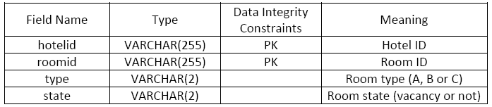

2.1.5 Order table: order
Table 5: Order table
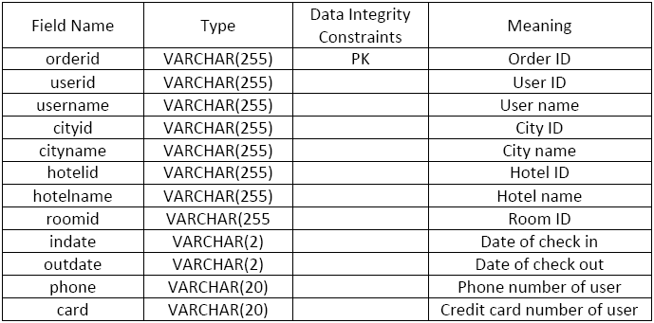

2.2 Main method specification
2.2.1 HotelClientHOPP
Table 6: Main Method of HotelClientUI
Method | Parameters | Return | Specification
register(String userID, String psw) | userID: user ID  psw: password | true/false | registrter a new user
logIn(String userID, String psw) | userID: user ID  psw: password | true/false | login system
quit() | null | void | quit system
query() | null | cityID:cityname | query cities
queryhotel(String line) | line: city ID | cityname:hotelID  +hotelname+priceA  +priceB+priceC | query hotels with city ID
book(String str) | str: hotel ID, room type | roomID | check vacancy of a hotel
order(String str) | str: userID, hotelID, roomID, username, indate, outdate, phone, card | true/false | make an order
manage(String str) | str: userID | orderID,username,  cityname,hotelname,  roomID,indate,  outdate,phone,card | show order information
delete(String orderid) | orderid: ID number of order | true/false | delete an order

2.2.2 BrokerServerHOPP
Table 7: Main Method of BrokerServerHOPP
Method | Parameters | Return | Specification
setup(String[] args) | args: {"–ORBInitialPort", "1235"} | null | setup a corba connection
getRMIconnection(int port) | port: port number of hotel server | null | get connection with a RMI server

2.2.3 DBManage
Table 8: Main Method of DBManage
Method | parameters | Return | Specification
validate(String userID, String psw) | userID: user ID  psw: password | true/false | check userID and password
create (String userID, String psw) | userID: user ID  psw: password | true/false | create a new user account
getXXXPort(String str) | str:  same parameter as XXX method | port number | get port number when conduct XXX method
getXXXMiddle(String str) | str:  same parameter as XXX method | middleware type | get middleware type when conduct XXX method
From this method specification above, we can easily understand the message transmission between client & broker server and broker server & hotel server. This specification includes enough details about message formats, which can help us to implement a client or server to handle the messages.

2.3 Class diagram
2.3.1 Class diagram of the Hotel Booking System with RMI hotel server
Figure 3: Class diagram of Hotel Booking System with RMI hotel server

2.3.2 Class diagram of the Hotel Booking System with Corba hotel server
Figure 4: Class diagram of Hotel Booking System with Corba hotel server
2.3.3 Class diagram of the Hotel Booking System with Web Service
Figure 5: Class diagram of Hotel Booking System with Web Service

3. System realization

3.1 User interface
3.1.1 Main user interface
Figure 6: Main user interface
Figure 6 is showing the main user interface of the Hotel Booking System. User can choose to register, login and quit.
3.1.2 Register interface
Figure 7: Register interface
Figure 7 is showing the register interface. After submitting the register information, no matter success or not, it will always show the information of the result and return to the main user interface.
Figure 8: Error message
Figure 8 is showing the error message of the register. When user submitted illegal register information, the system will show the tips of error message to help user to correct it.
3.1.3 Login interface
Figure 9: Login interface
Figure 9 is showing the login interface. After submitting the login information, if succeed, it will show the success information and turn into the homepage; if failed, it will show the fail information and return to the main user interface.
3.1.4 Homepage interface
Figure 10: Homepage interface
Figure 10 is showing the homepage interface of the Hotel Booking System. User can choose to query information, booking hotel, order management or logout.
3.1.5 Query interface
Figure 11: Query interface
Figure 11 is showing the query interface, when user enter this interface, system will show the all available cities and their cityID. When user enter the right cityID, it will list all available hotels and their information in the certain city and user can choose to book hotel or just return to the homepage. If user enter a wrong cityID, it will show the error message and return to the query interface.
3.1.6 Booking hotel interface
Figure 12: Booking hotel interface
Figure 12 is showing the booking hotel interface, when user enter this interface, system will require user to enter hotel ID and room type to check the vacancy. If there are rooms available, system will require user to enter more information to complete the order. Or, it will show information that the quested room is full and return to booking hotel interface. Whenever user submit wrong format of booking information, the system will show the error message and return to the booking hotel interface.
3.1.7 Order management interface
Figure 13: Order management interface
Figure 13 is showing the order management interface, when user enter this interface, system will list all order information of current user. User can choose to type in “back” to return the homepage, or to type in order ID to delete that order. When deleting order, if user submitted wrong order ID, the system will show error message and return to order management interface, or it will show success message and return.

3.2 Deployment diagram
Figure 14: Deployment diagram

